Removal of micropollutants from WWTP discharges: what about adsorption on activated carbon process?
Author ¹, Author ², Author ³.

Affiliation1
Affiliation2
Affiliation3

Résumé (Max 300 mots)
Times New Romain, 11, Interligne: 1.5, Justifier.

Insérer une figure/ résumé graphique

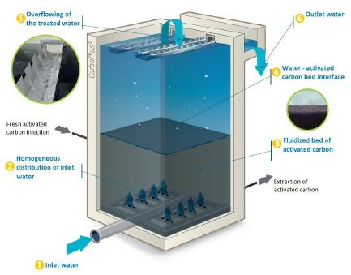

Références (maximum 4)
- J Margot, Kienle C, Magnet A, Weil M, Rossi L, De Alencastro L F, Abegglen C, Thonney D, Chèvre N and Schärer M (2013). Treatment of micropollutants in municipal wastewater: ozone or powdered activated carbon? Sci. Total Environ. 461: 480-498.
- J Margot, Rossi L, Barry D A and Holliger C (2015). A review of the fate of micropollutants in wastewater treatment plants. Wiley Interdisciplinary Reviews: Water 2(5): 457-487.
- S Martin Ruel, Choubert J-M, Budzinski H, Miège C, Esperanza M and Coquery M (2012). Occurrence and fate of relevant substances in wastewater treatment plants regarding Water Framework Directive and future legislations. Water Science and Technology 65(7): 1179-1189.
- A Tahar, Choubert J-M and Coquery M (2013). Xenobiotics removal by adsorption in the context of tertiary treatment: a mini review. Environmental Science and Pollution Research 20(8): 5085-5095.

Biographie (Max 100 mots)
Times New Romain, 11, Interligne: 1.5, Justifier.

Email: drXXXXXXX@xxxmail.com

